LAB 10
SPI Communication



Spring 2026
Embedded Systems Lab

Submitted By: Naveed Ahmad
Registration No: 22PWCSE2165
Class Section: B

Submitted to:

Engr. Muhammad Shahzad

June 25, 2026

Department of Computer Systems Engineering
University of Engineering and Technology

LAB 10
SPI COMMUNICATION
SPI (Serial Peripheral Interface) communication is a synchronous serial communication protocol used to transfer data between a microcontroller (master) and one or more peripheral devices (slaves) like sensors, displays, memory chips, etc.

Key Features
- Full-duplex: Data can be sent and received at the same time
- High speed: Faster than protocols like I²C
- Simple hardware: Uses a few dedicated lines

SPI Lines (Signals)

SPI typically uses 4 wires:
- MOSI (Master Out Slave In) : Data sent from master → slave
- MISO (Master In Slave Out) : Data sent from slave → master
- SCLK (Serial Clock) : Clock signal generated by the master to synchronize data
- SS / CS (Slave Select / Chip Select) : Used by the master to select which slave device to communicate with
TASK 01:
- Basic data transfer (loop back test) connect MOSI and MISO for arduino uno
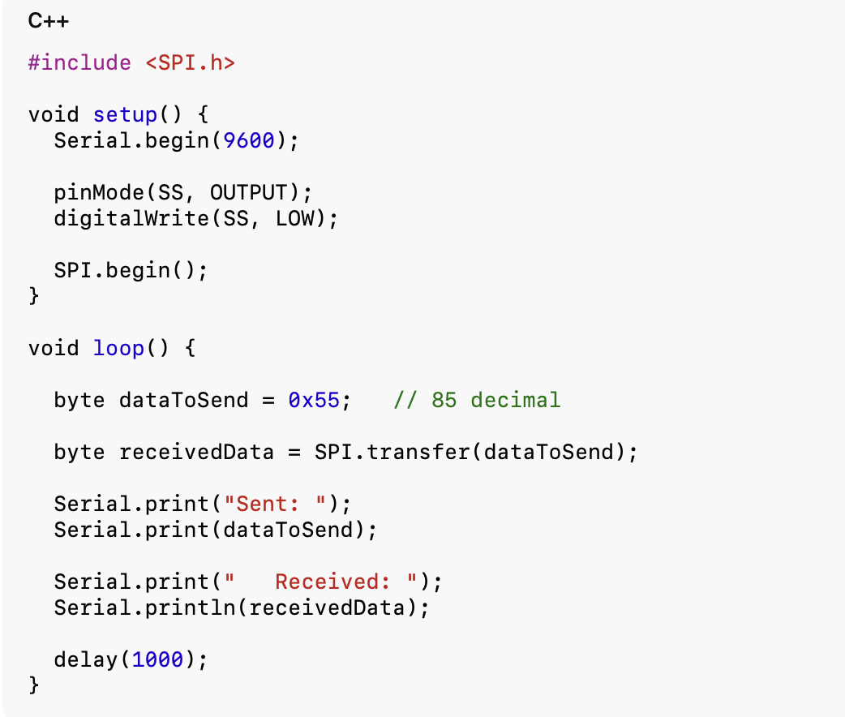
OUTPUT:
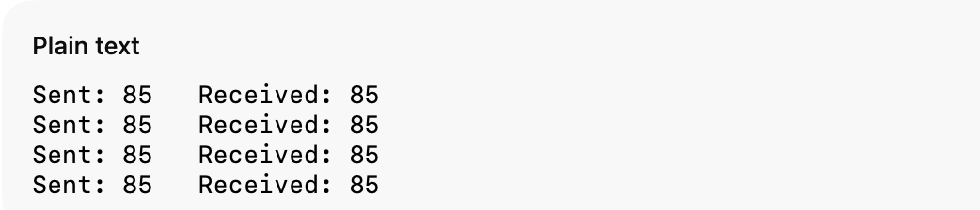

TASK 02
- Master sends data to slave. need two arduinos

Master Code

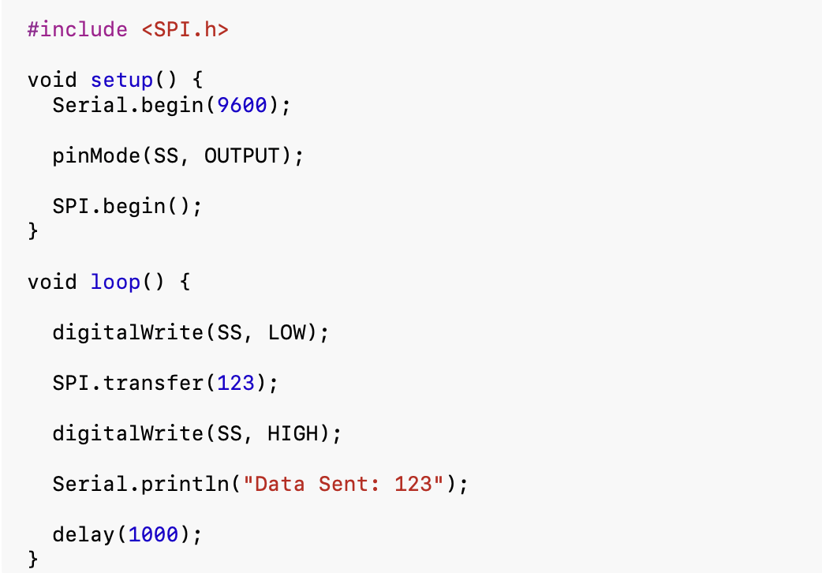

Slave Code:

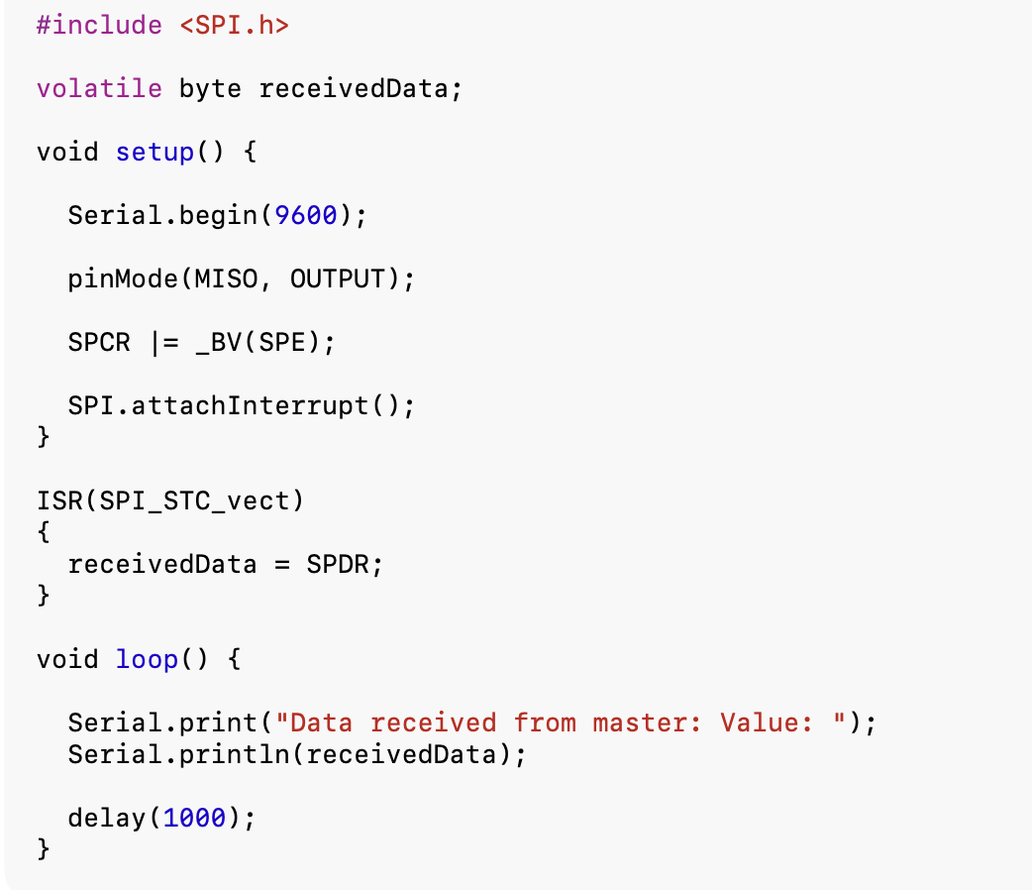
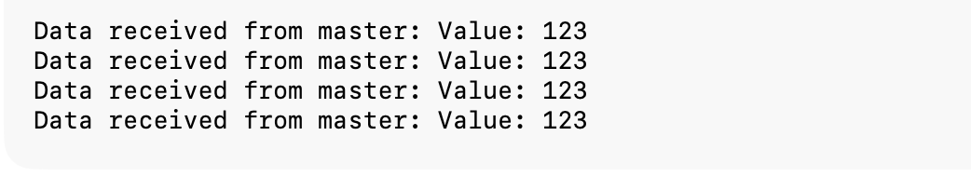

TASK 03

Master Reads Data from Slave

Master Code

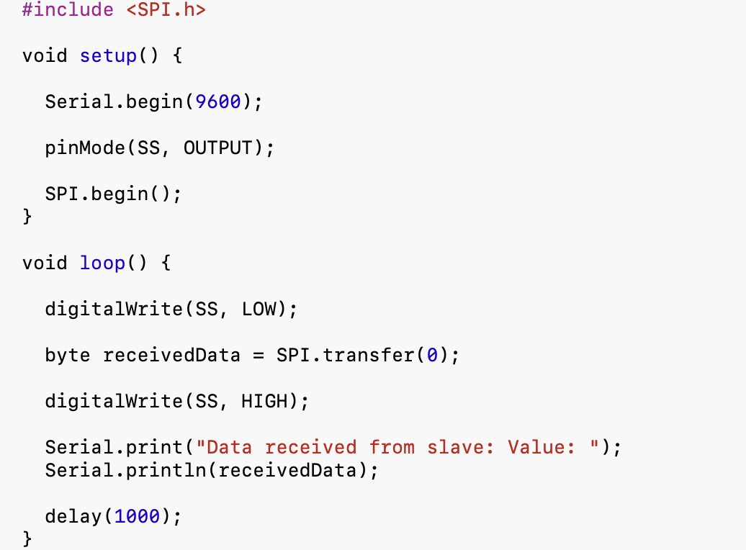
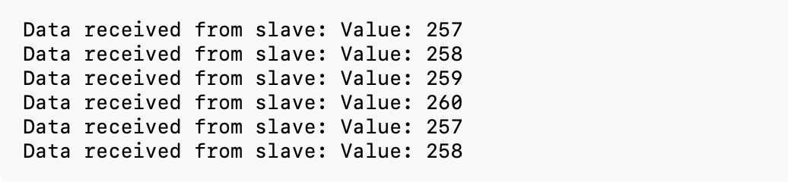

Slave Code
